**TITLE OF PROJECT**

## FACE RECOGNITION

END TERM REPORT

**by**

**ABHINIT KUMAR (B46)**

**RISHABH BANSAL**

**GitHub Link:** **https://github.com/abhinit1999/INT248_Project**

(**Section**: **KM073**)



**Student Declaration**

This is to declare that this report has been written by me. No part of the report is copied from other sources. All information included from other sources have been duly acknowledged. We aver that if any part of the report is found to be copied, we shall take full responsibility for it.

**Abhinit Kumar**

**Date:8th, November 2021**

## TABLE OF CONTENTS

**TITLE:** Face Recognition

1. Background and objectives of project assigned
   1. History
   2. Technique 1.2.1Traditional
      1. 3-Dimentional Recognition
      2. Skin Texture Analysis
      3. Thermal Cameras
   3. Outcomes of Facial Recognition
   4. Working Principle 2 Description of Project
   5. Description of Work Division in terms of Roles among Students
   6. Implementation of scheduled work of Project
   7. Technologies and Framework to be used
   8. SWOT Analysis achieved in project

# BONAFIDE CERTIFICATE

Certified that this project report “**FACE RECOGNITION**” is the bonafide work of “, **ABHINIT** who carried out the project work under my supervision.

### Signature of the Supervisor:

**Name of supervisor: Ankita Wadhawan**

LOVELY PROFESSIONAL UNIVERSITY, PUNJAB

### ID of Supervisor:

**Department of Supervisor:** Artificial Intelligence

# Objective Of the Project

A facial recognition system is a technology capable of identifying or verifying a person from a digital image or a video frame from a video source. There are multiple methods in which facial recognition systems work, but in general, they work by comparing selected facial features from given image with faces within a database. It is also described as a Biometric Artificial Intelligence based application that can uniquely identify a person by analyzing patterns based on the person's facial textures and shape.

### HISTORY:

During 1964 and 1965, Bledsoe, along with Helen Chan and Charles Bisson, worked on using the computer to recognize human faces (Bledsoe 1966a, 1966b; Bledsoe and Chan 1965). He

was proud of this work, but because the funding was provided by an unnamed intelligence agency that did not allow much publicity, little of the work was published.

**TECHNIQUE:** Essentially, the process of face recognition is performed in two steps. The first involves feature extraction and selection and the second is the classification of objects. Later developments introduced varying technologies to the procedure. Some of the most notable include the following techniques:

**TRADITIONAL:** Some face recognition algorithms identify facial features by extracting landmarks, or features, from an image of the subject's face. For example, an algorithm may analyze the relative position, size, and/or shape of the eyes, nose, cheekbones, and jaw.These features are then used to search for other images with matching features.

Other algorithms normalize a gallery of face images and then compress the face data, only saving the data in the image that is useful for face recognition. A probe image is then compared with the face data.

Popular recognition algorithms include principal component analysis using eigenfaces, linear discriminant analysis, elastic bunch graph matching using the Fisherface algorithm.

**3-DIMENSIONAL RECOGNITION:** Three-dimensional face recognition technique uses 3D sensors to capture information about the shape of a face. This information is then used to identify distinctive features on the surface of a face, such as the contour of the eye sockets, nose, and chin.

One advantage of 3D face recognition is that it is not affected by changes in lighting like other techniques. It can also identify a face from a range of viewing angles, including a profile view. Three-dimensional data points from a face vastly improve the precision of face recognition.

### SKIN TEXTURE ANALYSIS:

Another emerging trend uses the visual details of the skin, as captured in standard digital or scanned images. This technique, called Skin Texture Analysis, turns the unique lines, patterns, and spots apparent in a person's skin into a mathematical space.

### THERMAL CAMERAS:

A different form of taking input data for face recognition is by using thermal cameras, by this procedure the cameras will only detect the shape of the head and it will ignore the subject accessories such as glasses, hats, or makeup. Unlike conventional cameras, thermal cameras can capture facial imagery even in low-light and nighttime conditions without using a flash and exposing the position of the camera.

**OUTCOMES OF FACIAL RECOGNITION**

Facial recognition is a powerful technology, but it must be used wisely. On one hand, it brings immense advantage to the companies and end-users, helps them enhance their security and track down the trespassers.

**WORKING PRINCIPLE:**

Step 1. A picture of your face is captured from a photo or video. Your face might appear alone or in a crowd. Your image may show you looking straight ahead or nearly in profile.

Step 2. Facial recognition software reads the geometry of your face. Key factors include the distance between your eyes and the distance from forehead to chin. The software identifies facial landmarks — one system identifies 68 of them — that are key to distinguishing your face. The result: your facial signature.

Step 3. Your facial signature — a mathematical formula — is compared to a database of known faces. And consider this: at least 117 million Americans have images of their faces in one or more police databases. According to a May 2018 report, the FBI has had access to 412 million facial images for searches.

Step 4. A determination is made. Your faceprint may match that of an image in a facial recognition system database.

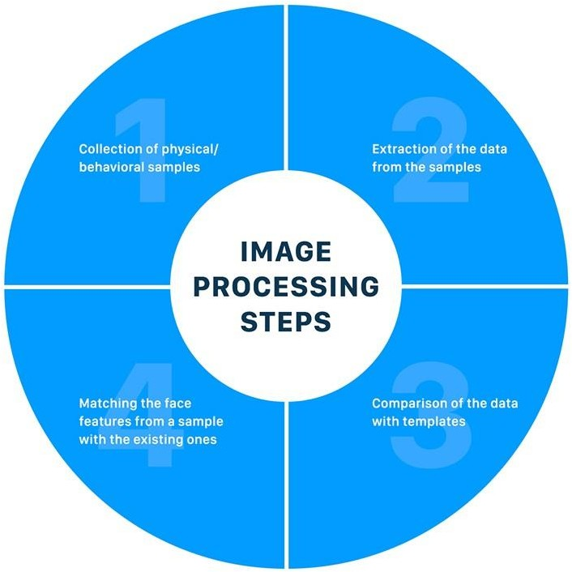

**Technologies and Framework to be used:**

The most common framework used in this project is “OpenCV “ OpenCV-**Python** is a library of **Python** bindings designed to solve computer vision problems, Machine learning and Facial Recognition System.

**SWOT Analysis achieved in project:**

The report discusses many vital industry facets that influence Global image Recognition Industry acutely which includes extensive study of competitive edge, latest technological advancements, region-wise industry environment, contemporary market and manufacturing trends, leading market contenders, and current consumption tendency of the end user. The report also oversees market size, market share, growth rate, revenue, and CAGR reported previously along with its forecast estimation.

Image recognition, in the context of machine vision, is the ability of software to identify objects, places, people, writing and actions in images. Computers can use machine vision technologies in combination with a camera and artificial intelligence software to achieve image recognition.

**Github Link: https://github.com/abhinit1999/INT248_Project**

Some Sample Output Of this Project:

